## Correct Refrigerant Charge

### Author

Chris Balbach, PSD Consulting

### Description

This energy efficiency measure (EEM) applies a performance degradation factor to all existing DX heating and cooling coils in a model, representing the estimated impact of a 30% refrigerant undercharge scenario. An estimated degradation in performance equal to a (11.1% / 2.77%) reduction of the DX (cooling / heating) coil’s current rated COP is applied. This value represents an estimated coil performance degradation associated with a 30% refrigerant undercharge scenario. The value for the degradation factor is based on research work recently performed by NIST in collaboration with ACCA and published under IEA Annex 36 in 2015.

### Modeler Description

This energy efficiency measure (EEM) loops through all DX Coil objects of these types: 1) OS:CoilCoolingDXMultiSpeed, 2) OS:CoilCoolingDXSingleSpeed, 3) OS:CoilCoolingDXTwoSpeed, 4) OS:CoilCoolingDXTwoStageWithHumidityControlMode, 5) OS:CoilCoolingDXSingleSpeed, 6) OS:CoilCoolingWaterToAirHeatPump:EquationFit and 7) OS:CoilCoolingWaterToAirHeatPump:EquationFit. For each DX Cooling Coil object type, the initial Rated COP is modified (reduced) by 11.1%, representing a 30% refrigerant undercharge scenario. For each DX Heating Coil object type, the initial Rated COP is modified (reduced) by 8.24%, representing a 30% refrigerant undercharge scenario.

### Use Case Types

Retrofit EE

### Arguments

No arguments

### Initial Condition Message

The initial model contained {X} applicable DX Heating coil objects for which this measure is applicable.

The initial model contained {Y} applicable DX Cooling coil objects for which this measure is applicable.

### Final Condition Message

{A} DX Heating Coil objects were modified to incorporate estimated performance degradation for a 30% (by mass) refrigerant undercharge scenario.

{B} DX Cooling Coil objects were modified to incorporate estimated performance degradation for a 30% (by mass) refrigerant undercharge scenario.

### Not Applicable Messages

The model contains no DX Heating or DX Cooling coil objects for which this measure is applicable.

### Warning Messages

None

### Information Messages

Did something to object 1. Etc.

### Error Messages

### None

### Code Outline

Loop through each type of object described below to find these objects. Modify the Rated COP by (1-0.111)

If object type = OS:CoilCoolingDXMultiSpeed

1. Read OS:CoilCoolingDXMultiSpeed .stages (maximum number of stages)
   1. For each stage, read OS:[CoilCoolingDXMultiSpeedStageData](https://openstudio-sdk-documentation.s3.amazonaws.com/cpp/OpenStudio-1.8.0-doc/model/html/classopenstudio_1_1model_1_1_coil_cooling_d_x_multi_speed_stage_data.html#ae06a0fc8a8a626cb83503d4b4d6ec1c9)
      1. OS:[CoilCoolingDXMultiSpeedStageData](https://openstudio-sdk-documentation.s3.amazonaws.com/cpp/OpenStudio-1.8.0-doc/model/html/classopenstudio_1_1model_1_1_coil_cooling_d_x_multi_speed_stage_data.html#ae06a0fc8a8a626cb83503d4b4d6ec1c9).grossRatedCoolingCOP = OS:[CoilCoolingDXMultiSpeedStageData](https://openstudio-sdk-documentation.s3.amazonaws.com/cpp/OpenStudio-1.8.0-doc/model/html/classopenstudio_1_1model_1_1_coil_cooling_d_x_multi_speed_stage_data.html#ae06a0fc8a8a626cb83503d4b4d6ec1c9).grossRatedCoolingCOP * (1-0.111)

If object type = OS:CoilCoolingDXSingleSpeed

1. OS:[CoilCoolingDXSingleSpeed.ratedCOP = OS:[CoilCoolingDXSingleSpeed.ratedCOP](https://openstudio-sdk-documentation.s3.amazonaws.com/cpp/OpenStudio-1.8.0-doc/model/html/classopenstudio_1_1model_1_1_coil_cooling_d_x_multi_speed_stage_data.html#ae06a0fc8a8a626cb83503d4b4d6ec1c9)](https://openstudio-sdk-documentation.s3.amazonaws.com/cpp/OpenStudio-1.8.0-doc/model/html/classopenstudio_1_1model_1_1_coil_cooling_d_x_multi_speed_stage_data.html#ae06a0fc8a8a626cb83503d4b4d6ec1c9) * (1-0.111)

If object type = OS:CoilCoolingDXTwoSpeed

1. OS:[CoilCoolingDXTwoSpeed](https://openstudio-sdk-documentation.s3.amazonaws.com/cpp/OpenStudio-1.8.0-doc/model/html/classopenstudio_1_1model_1_1_coil_cooling_d_x_two_speed.html#a04e7c27436550a40958a2af00ea76a55).ratedHighSpeedCOP = OS:[CoilCoolingDXTwoSpeed](https://openstudio-sdk-documentation.s3.amazonaws.com/cpp/OpenStudio-1.8.0-doc/model/html/classopenstudio_1_1model_1_1_coil_cooling_d_x_two_speed.html#a04e7c27436550a40958a2af00ea76a55).ratedHighSpeedCOP * (1-0.111)
2. OS:[CoilCoolingDXTwoSpeed](https://openstudio-sdk-documentation.s3.amazonaws.com/cpp/OpenStudio-1.8.0-doc/model/html/classopenstudio_1_1model_1_1_coil_cooling_d_x_two_speed.html#a04e7c27436550a40958a2af00ea76a55).ratedLowSpeedCOP = OS:[CoilCoolingDXTwoSpeed](https://openstudio-sdk-documentation.s3.amazonaws.com/cpp/OpenStudio-1.8.0-doc/model/html/classopenstudio_1_1model_1_1_coil_cooling_d_x_two_speed.html#a04e7c27436550a40958a2af00ea76a55).ratedLowSpeedCOP * (1-0.111)

If object type = OS:CoilCoolingDXTwoStageWithHumidityControlMode

1. OS:CoilCoolingDXTwoStageWithHumidityControlMode.normalModeStage1CoilPerformance.grossRatedCOP = OS:CoilCoolingDXTwoStageWithHumidityControlMode.normalModeStage1CoilPerformance.grossRatedCOP * (1-0.111)
2. OS:CoilCoolingDXTwoStageWithHumidityControlMode.normalModeStage1Plus2CoilPerformance.grossRatedCOP = OS:CoilCoolingDXTwoStageWithHumidityControlMode.normalModeStage1Plus2CoilPerformance.grossRatedCOP * (1-0.111)
3. OS:CoilCoolingDXTwoStageWithHumidityControlMode.dehumidificationMode1Stage1CoilPerformance.grossRatedCOP = OS:CoilCoolingDXTwoStageWithHumidityControlMode.dehumidificationMode1Stage1CoilPerformance.grossRatedCOP * (1-0.111)
4. OS:CoilCoolingDXTwoStageWithHumidityControlMode.dehumidificationMode1Stage1Plus2CoilPerformance.grossRatedCOP = OS:CoilCoolingDXTwoStageWithHumidityControlMode.dehumidificationMode1Stage1Plus2CoilPerformance.grossRatedCOP * (1-0.111)

If object type = OS:CoilHeatingDXSingleSpeed

1. OS:[CoilHeatingDXSingleSpeed.ratedCOP = OS:[CoilHeatingDXSingleSpeed.ratedCOP](https://openstudio-sdk-documentation.s3.amazonaws.com/cpp/OpenStudio-1.8.0-doc/model/html/classopenstudio_1_1model_1_1_coil_cooling_d_x_multi_speed_stage_data.html#ae06a0fc8a8a626cb83503d4b4d6ec1c9)](https://openstudio-sdk-documentation.s3.amazonaws.com/cpp/OpenStudio-1.8.0-doc/model/html/classopenstudio_1_1model_1_1_coil_cooling_d_x_multi_speed_stage_data.html#ae06a0fc8a8a626cb83503d4b4d6ec1c9) * (1-0.0277)

### Tests

**This measure applies to:**

1. Secondary School

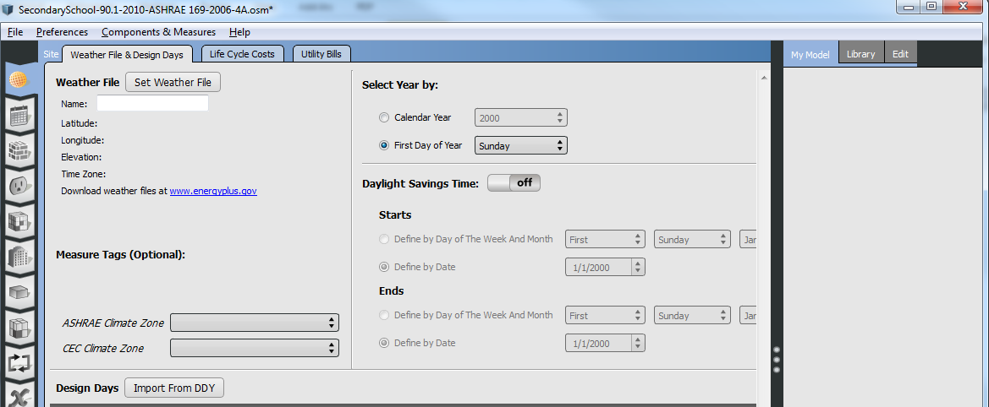

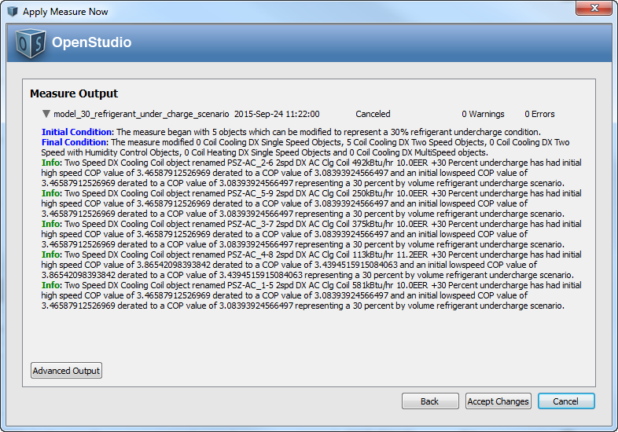

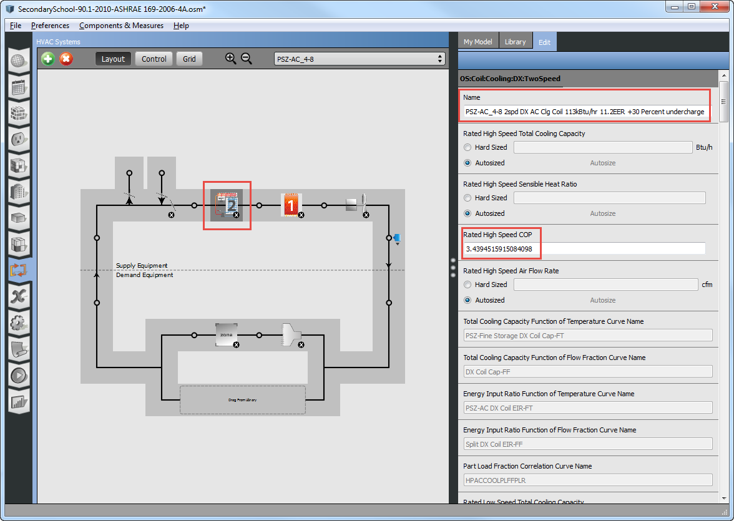

1. Primary School
2. Outpatient Healthcare
3. Large Office

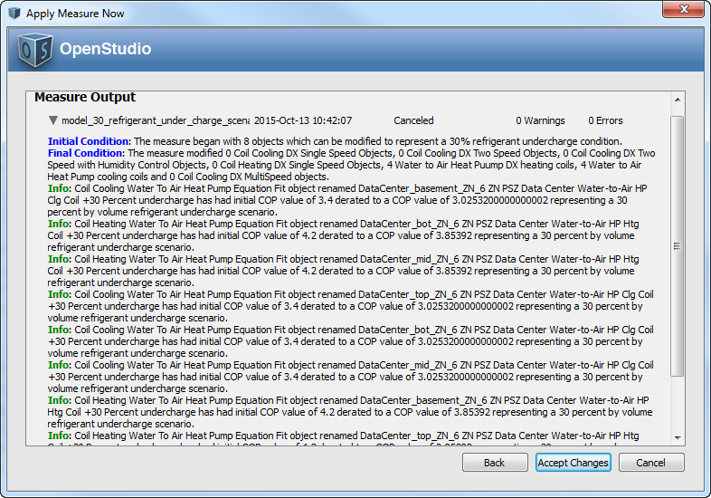

1. Warehouse
2. Midrise Apartment
3. Small Office
4. Medium Office

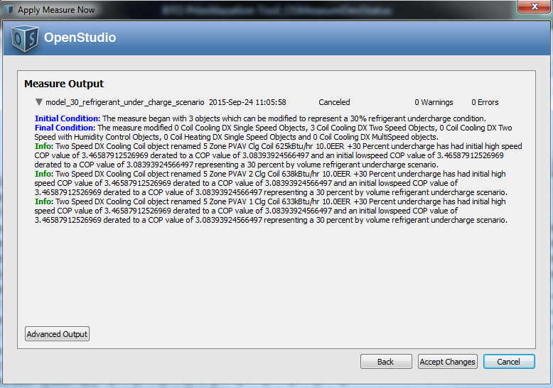

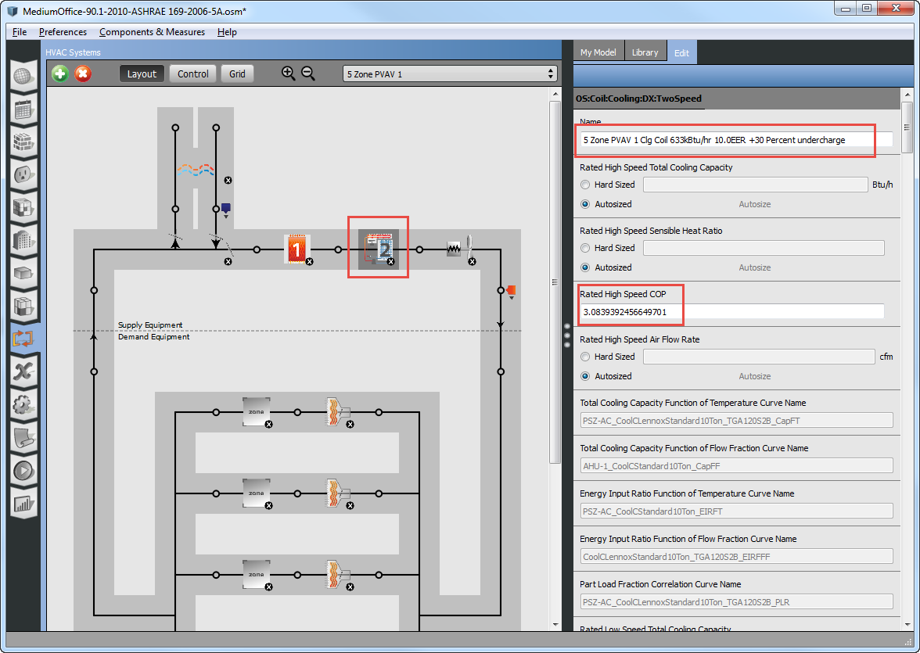

1. Stand-Alone Retail
2. Strip Mall
3. Supermarket
4. Quick Service Restaurant
5. Full Service Restaurant
6. Small Hotel

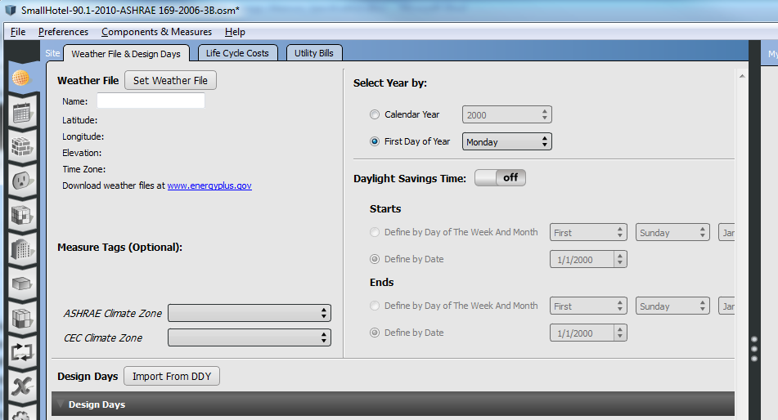

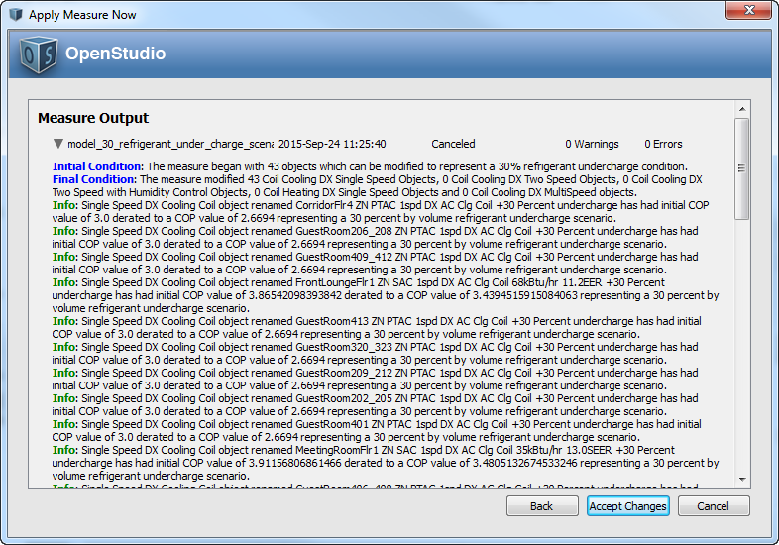

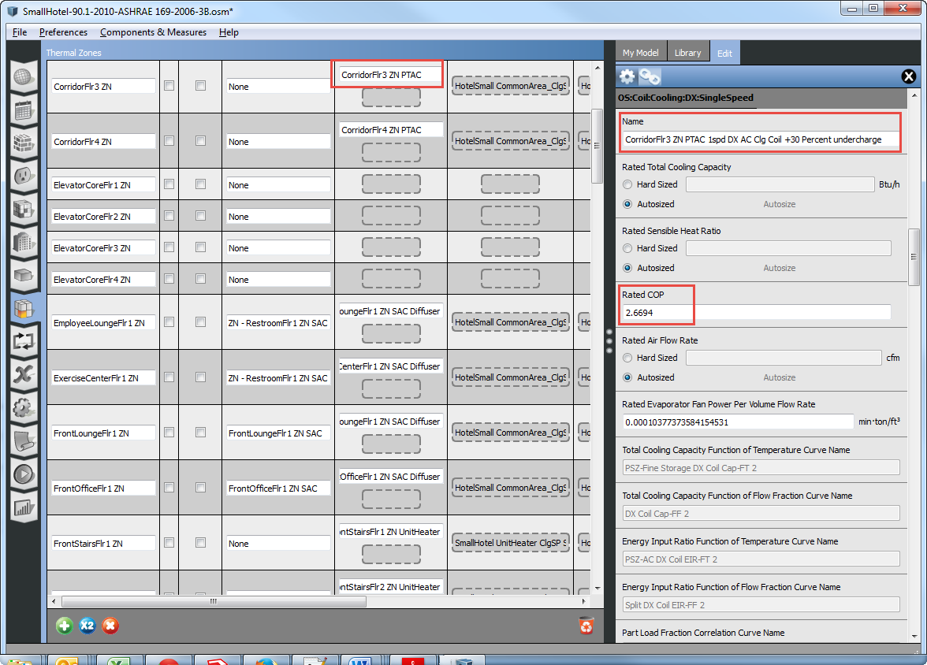

**This measure does not apply to:**

1. Hospital
2. Large Hotel

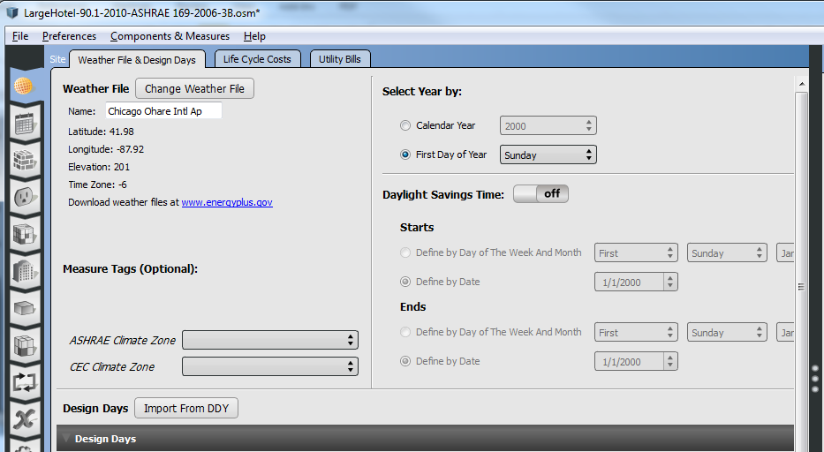

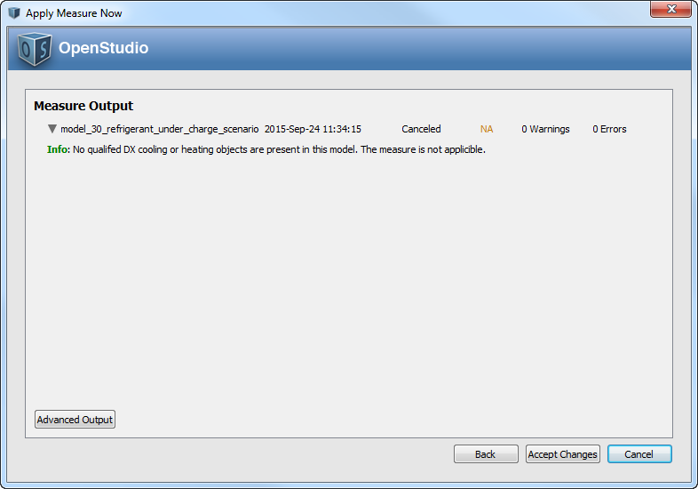

**Test results:**

Run the simulation using prototype .osm files, examine the results, cut and paste some before/after screenshots/evidence that makes you think that the measure is working correctly, including generating messages.

**Engineering Notes:**

The coil performance degradation factors calculated to represent a 30% refrigerant undercharge scenario were determined by recently published research conducted by NIST/IEA under IEA Annex 36: *Quality Installation/Quality Maintenance Sensitivity Analysis*

“Effect of Installation Faults on Air-to-Air Heat Pump Performance”:

[*http://www.nist.gov/manuscript-publication-search.cfm?pub_id=917726*](http://www.nist.gov/manuscript-publication-search.cfm?pub_id=917726)

“NIST Technical Note 1848: Sensitivity Analysis of Installation Faults on Heat Pump Performance”: <http://nvlpubs.nist.gov/nistpubs/TechnicalNotes/NIST.TN.1848.pdf>

“Normalized Performance Parameters for a Residential Heat Pump in the Cooling Mode with Single Faults Imposed”: <http://www.nist.gov/customcf/get_pdf.cfm?pub_id=910617>

The published research recommends an upper fault limit of ***30% undercharge*** (where % = % mass below the correct (no fault) charge). A spreadsheet implementation of the published heat pump performance degradation correlations (single fault approach) using national average outdoor conditions and seasonal indoor temperatures of 72°F was used to generate the following results:

**30%** refrigerant undercharge = **11.10%** reduction from nameplate ***Cooling*** COP

**30%** refrigerant undercharge = **2.77%** reduction from nameplate ***Heating*** COP

For Reference:

**20%** refrigerant undercharge = **6.90%** reduction from nameplate Cooling COP

**20%** refrigerant undercharge = ~**0.00.%** reduction from nameplate Heating COP

**10%** refrigerant undercharge = **3.33%** reduction from nameplate Cooling COP

**10%** refrigerant undercharge = **~ 0%** reduction from nameplate Heating COP